Energy efficient OFDM using water filling algorithm

Author- Neha Mishra

**Abstract**- In this paper, an algorithm called Water-filling algorithm is presented for allocating power in Orthogonal Frequency Division Multiplexing (OFDM). It is shown that the water-filling algorithm used in usual OFDM systems is a proficient way of improving the capacity of the channel. In the designs for wireless communications, important roles played by Water-filling solutions such as in transmit covariance matrix design. Application of the analogy of pouring water over a pool with fluctuating bottom is a traditional understanding. A lot of variations in water-filling solutions have been revealed during the evolution of wireless networks. A crucial issue for the realistic use of water-filling solutions is algorithm design, which is not given much attention in the prose. This technique can be used for systems with different performance metrics and constraints in power and gives basic information in finding the optimization solution values and. The results of MATLAB simulation proves in this paper that our proposed algorithm can result in the optimal power allocation performance within minimal time in comparison with other methods used in OFDM.

**KEYWORDS**- orthogonal frequency division multiplexing, water-filling algorithm, power allocation, energy efficiency.

# INTRODUCTION

In the initial stage, the communication capacity was sufficient for the traditional voice and data services. But, with the fast increase of data traffic because of bandwidth-intensive applications like HD Televisions and mobile videos, the communication capacity slowly leads to highest limit nowadays. A key challenge is to is to improve the spectral efficiency to fulfill the increasing demand for higher capacity over communication channels. Hence, with rapid development of wireless communication, limited spectrum is a serious issue and frequency spectrum has become a crucial resource for us. A central role in the optimization of these systems is played by Water-filling technique plays. There is no doubt that this technique is among the most important and fundamental outcomes in signal processing ,wireless communication and optimizations of networks including transmitter- receiver optimization, training optimization, resource allocation, and so on.

Orthogonal Frequency Division Multiplexing (also known as OFDM) is a multiple carrier digital communication technique to solve both problems. It merges a lot of carriers having low data rate to make a communication system with high data rate. This type of multiple carrier transmission schemes that has been considered to be an option to provide broadband and data transmission with high speed over wireless channels. A key problem in OFDM is the power among users using the same channel and allocation of the OFDM subcarriers. Also, improvement can be done in OFDM channel capacity of fading environments. Previous allocation algorithms cannot ensure equity beforehand.

Another point to note here about why the proposed algorithm is an efficient option in OFDM channels is the primitive called Peak to Average Power ratio. The coherent summation of subcarriers in OFDM leads to large Peak to Average Ratio. In such cases, N number of signals having the same phase can produce a peak power which is equal to N times the average power of the channel. Those large peaks lead to power amplifier being saturated, disturbance in out of band energy and inter modulation products in sub carriers. Therefore, it is worthy to reduce PAPR using this proposed algorithm.

**Description**

A common name given to the ideas in the design of [communication systems](https://en.wikipedia.org/wiki/Communication_systems) and practice for [equalization](https://en.wikipedia.org/wiki/Adaptive_equalizer) techniques in wireless communication is water filling algorithm. As the name suggests, considering that the water gets to its level even after getting filled in a section inside a vessel with different outlets, the amplifier systems in the network repeaters in communication channels or receivers increase each channel till the expected power level is reached to be used for the channel impairments. The water-filling, also known as water pouring, algorithm give increased or decreased power and bits to some subcarriers with smaller or larger SNR for giving the maximum channel capacity in output. This signifies that all the information of channel state information is needed in this algorithm on the transmitter side for each subcarrier. When the transmitter gets a stable data rate, power, coding scheme for the channel variations in the capacity of a fading channel having information of side channels at both the receiver and transmitter, maximum output is obtained. The optimization in power allocation which is achieved in this case, is a “water-filling” in time, where data rate and power are increased in favorable channel situations and decreased in unfavorable channel conditions. The result can be considered to be a as a set of atomic concurrent channels, such that the sum of capacities on each channel gives the total capacity with power allocated in an optimized manner in the channels. The capacity of this channel is calculated at an initial stage and is an outcome of an optimal power allocation that water-fill over both time and frequency.

**Power Allocation:**

The maximum transmission rate that the channel can support is called the Shannon capacity of a communicating channel, and it improves with larger signal to noise power ratio (SNR) and larger bandwidth. Though, if we make bandwidths larger it gives us a higher noise power. Hence, instead of the bandwidth it is the Signal to Noise ratio that plays the important part in handling the output data transmission capacity of a channel.

In this paper, we study about energy efficient orthogonal frequency division multiplexing (OFDM) channel. Our goal is to give the maximum energy efficiency (EE), and we reduce the power of the total active subcarriers. The simplified answer leads us to use a water-filling bit allocation which is bidirectional so as to reduce the transmit power in an overall manner.

For an instance, in an OFDM communication system :

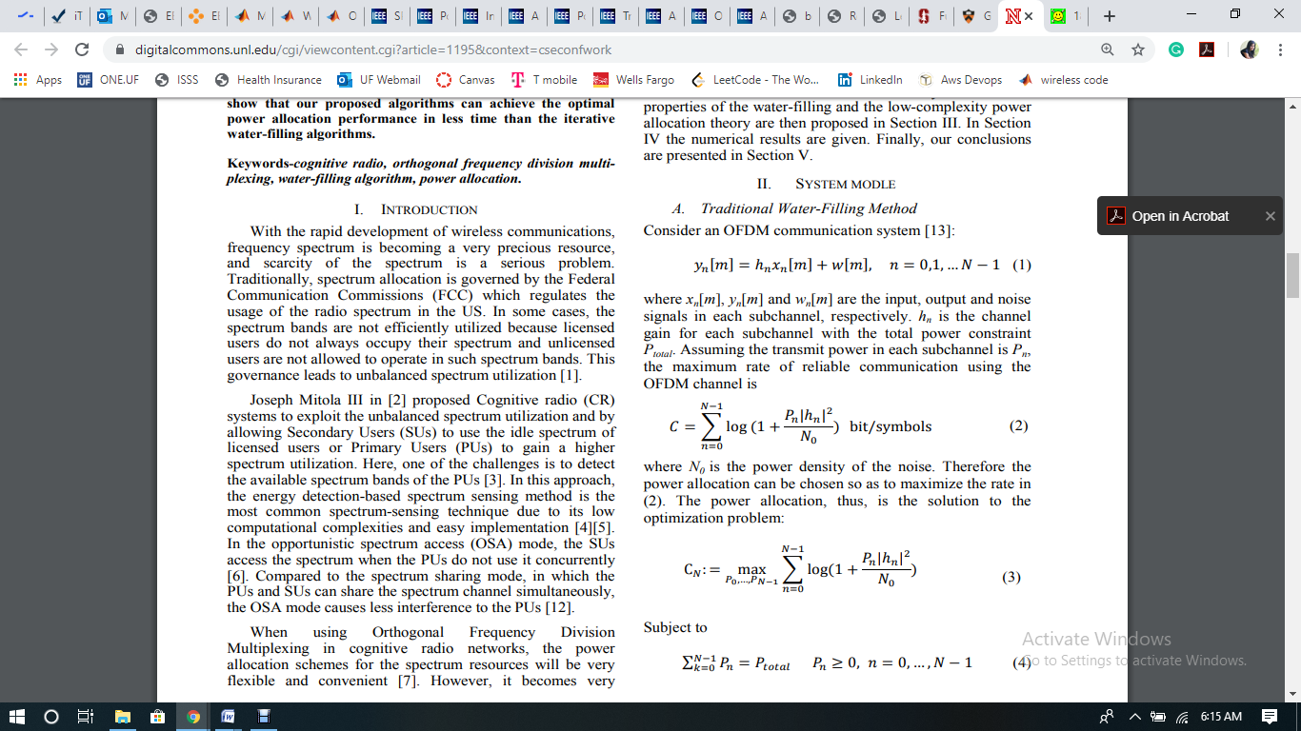

Where, xn[m] = input, yn[m] = output and wn[m] = noise signals in every sub channel. hn is considered to be the gain of the channel for each sub channel with the overall power constraint Ptotal. Let us consider that the power being transmitted within every sub channel is Pn, the maximum rate of reliable communication in an OFDM channel is



where N0 = density of power in the noise. Hence, the power allocation may be selected so that the rate is considered to be maximum in above equation. Therefore, the power allocation is the solution to the optimization problem:



In relation to:

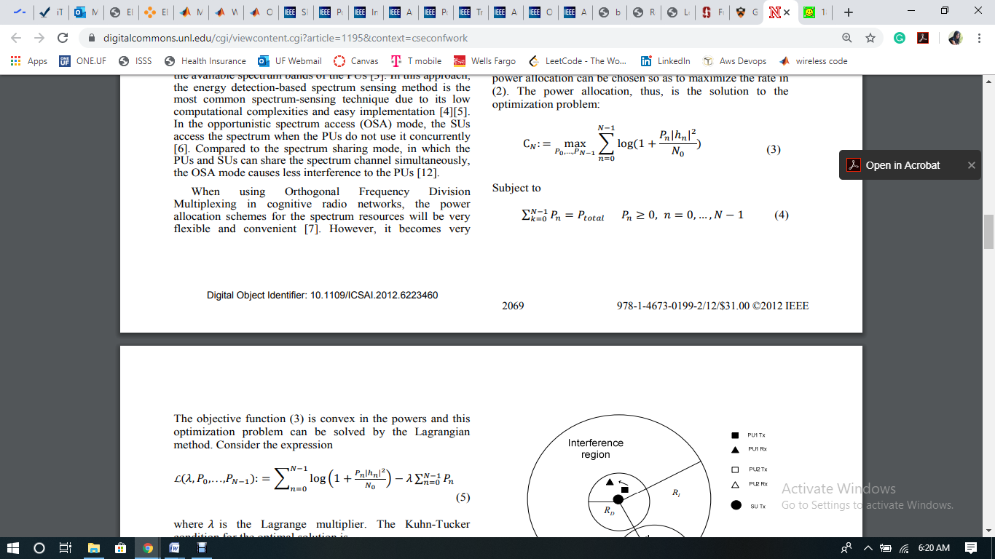

The optimal power allocation can be specifically calculated. The objective function is convex in the powers and this problem of optimization can be calculated by the Lagrangian method. Assume the expression:

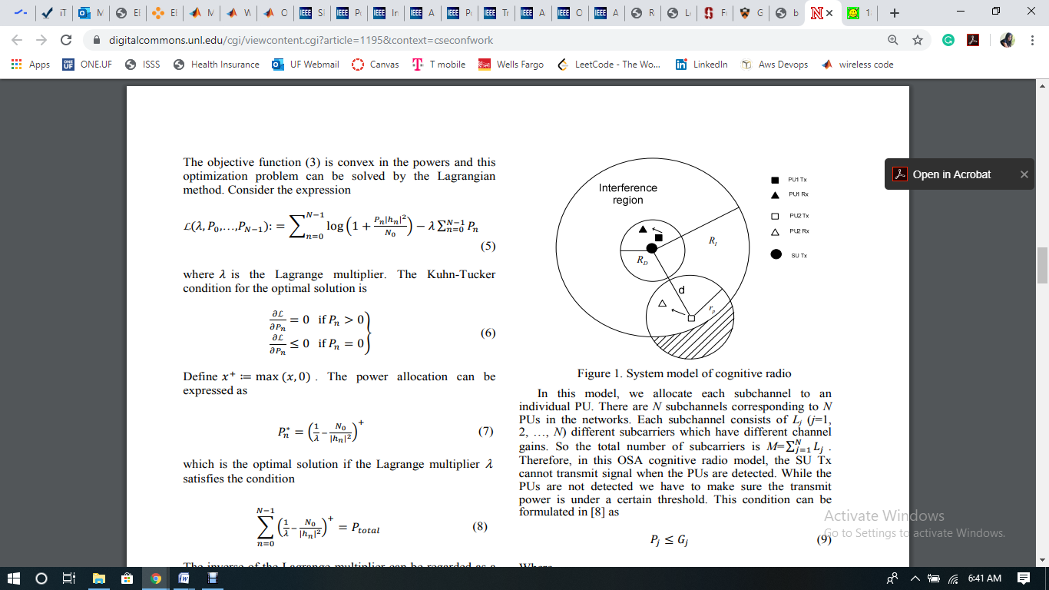

In which, λ = Lagrange multiplier.

The Kuhn-Tucker condition for optimizing power allocation is given as:

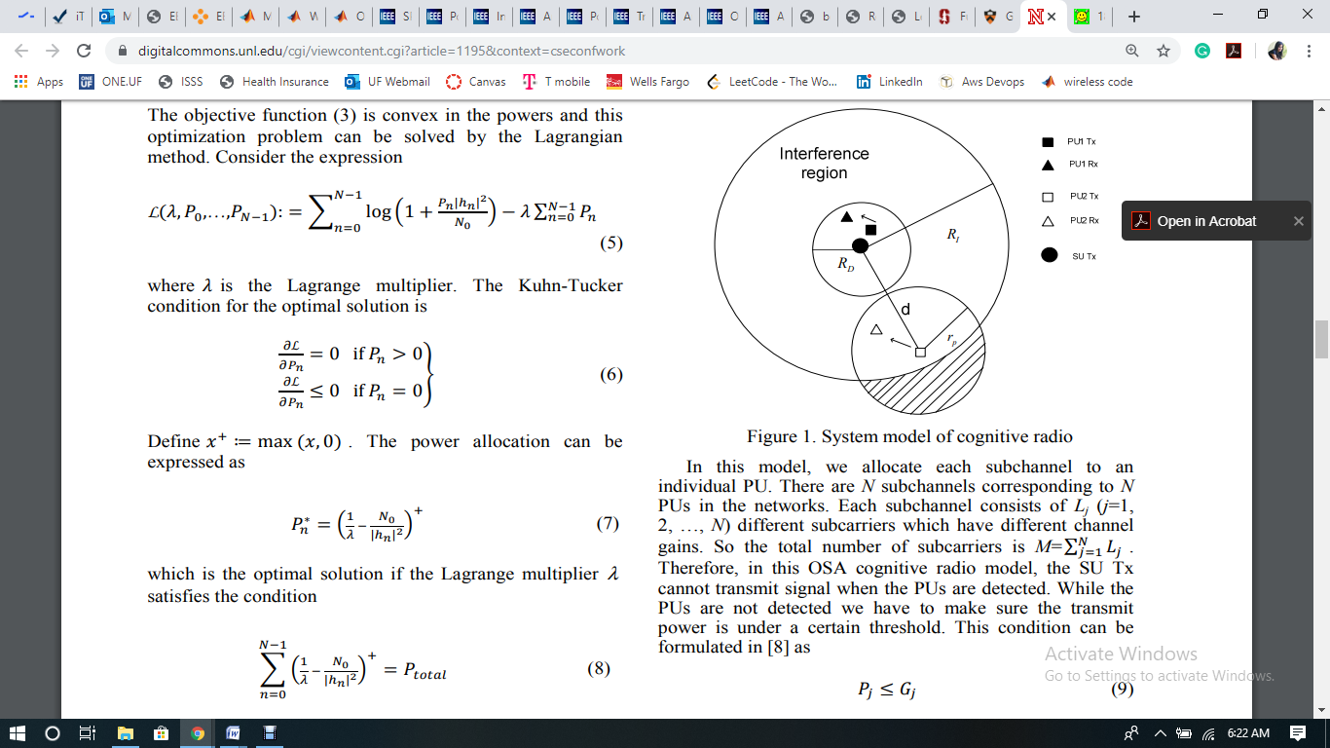

Define x + := max(x, 0).

The power allocation is given as:



This fulfills the conditions explained previously and is hence optimal, with the known Lagrange multiplier λ selected so as to meet the power constraint:



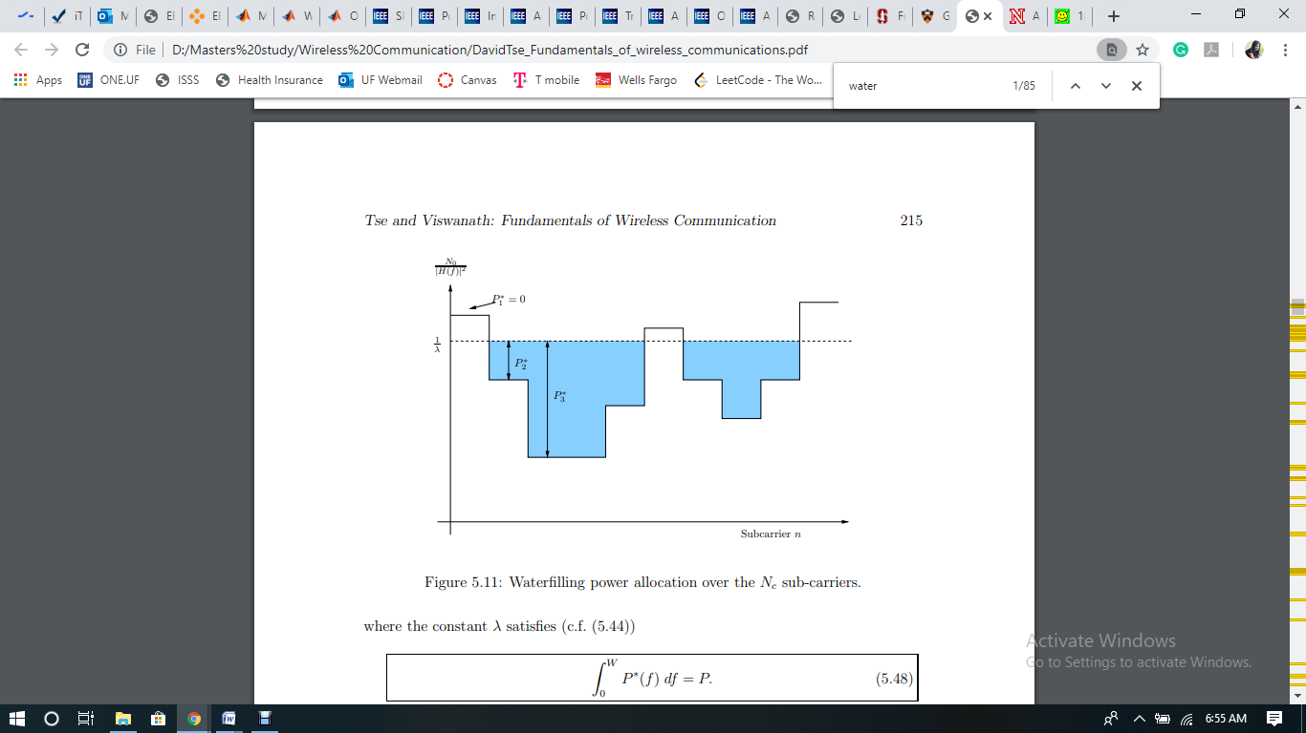

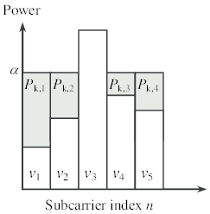

Above picture gives an idea of the strategy to be used for allocating power optimally in a system having OFDM. Assume the values to be N0/|hn| 2 shown in relation with the index of sub-carrier n = from zero till Nc − 1, to cover till the lowest level of a vessel. If P units of water for each sub-carrier are covered inside the vessel, the allocated power for that sub-carrier can be considered to be equal to the depth of the water at sub-carrier n, and 1/λ = height of the water surface. Therefore, this technique for optimization is called **water** **pouring or water filling** .

Point to note here is that the lowest level of the vessel is not under the water for some subcarriers and is considered to be having zero power to be assigned to them. In these sub-carriers, the channel is quite weak for it to be used to send the information. For most of the usual cases, the transmitter assigns extra power to the worthwhile sub carriers, having benefit of the superior channel conditions in comparison, and inferior or even zero power to the weaker carriers.

Note that:

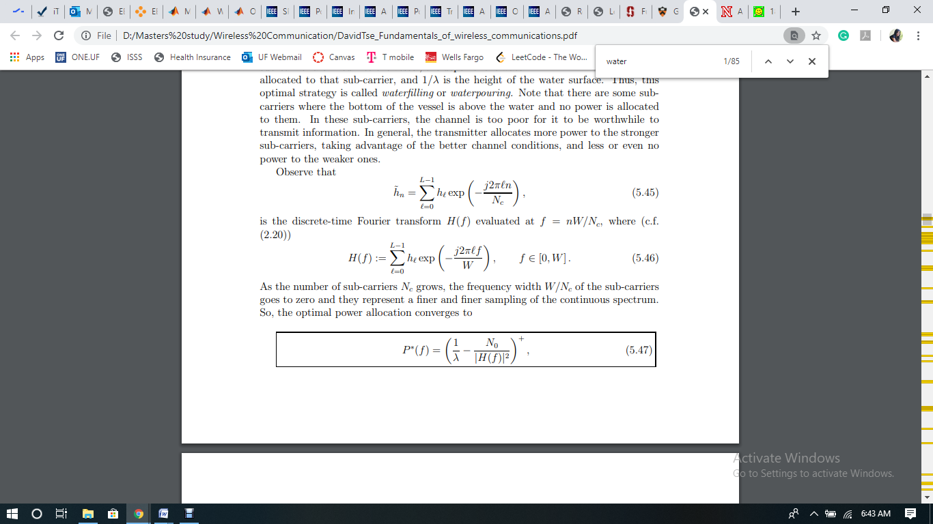

is the discrete-time Fourier transform H(f) evaluated at f = nW/Nc, where



When the sub-carriers count Nc increases gradually, the width of frequency W/Nc of the sub carriers becomes zero and it represents a better and better sampling of the whole spectrum. Hence, the optimized allocation of power can be represented as:



where the constant λ satisfies

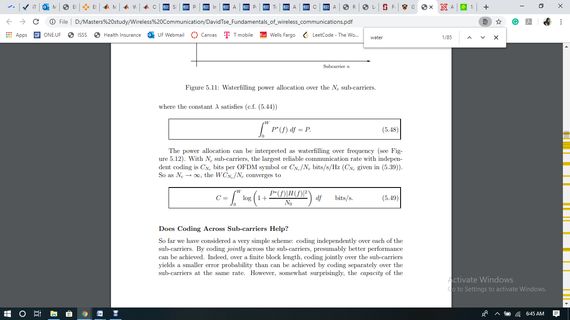

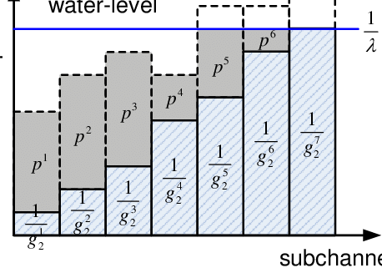

The allocation of power can be understood as water filling in terms of frequency (as given in below figure). Having Nc as the number of sub carriers, the maximum dependable communication rate combined with independent coding is CNc bits per OFDM symbol or CNc /Nc bits/s/Hz (CNc given in (5.39)). So as Nc → ∞, the WCNc /Nc converges to



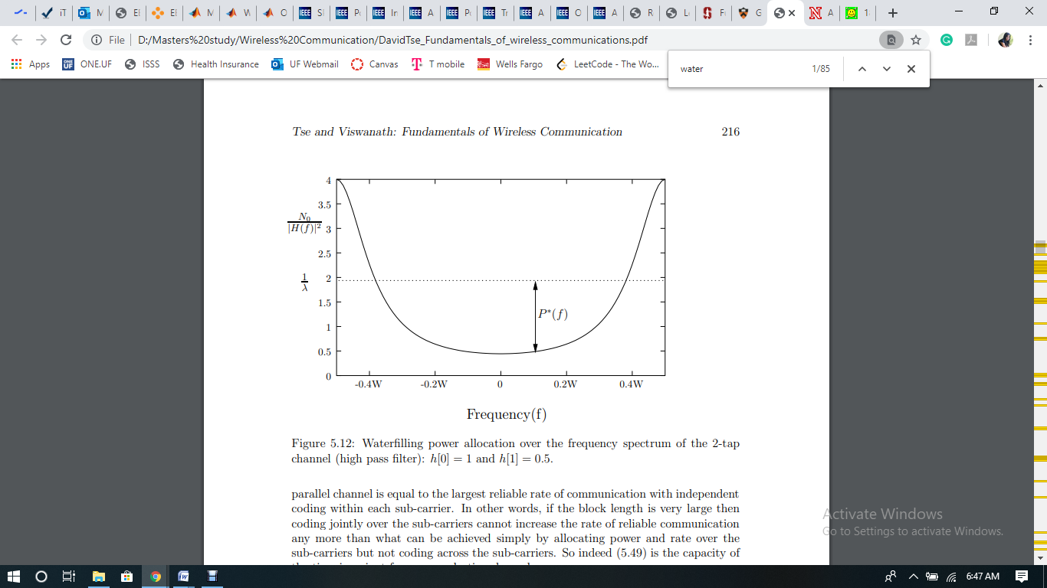

**Evaluation**

To evaluate the above derived formula of water filling technique, I have performed a MATLAB simulation and generated a graph of Power vs. Sub channel indices. As per the MATLAB code used, OFDM modulation splits the whole bandwidth in N number of sub channels. By utilizing a lot of sub channels leads to each sub channel to become a flat fading channel if the correct cyclic prefix is used till the last of every symbol in OFDM. Using this water filling algorithm we can allocate extra power to sub channels that are in favorable condition and can allocate zero power to sub channels having unfavorable conditioned such as sub channels which have deep fading. At one stage, some sub channels are given negative power due to the formula of optimization. Later, those sub channels are not allowed to use any power and this process is iterated for the rest of the sub channels, till the time all the sub channels are covered and are allocated the positive power. Below is the expected output graph of my code:

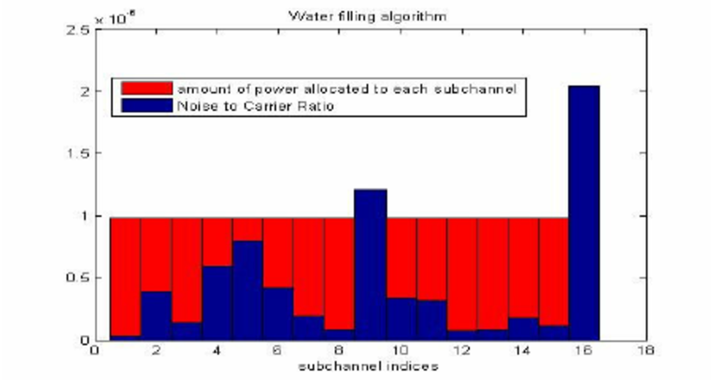

**Related work**

There are some existing techniques which are used to increase the channel capacity of OFDM channel, but most of them have their own disadvantages. Below are some of the examples of such techniques-

1. Robust channel estimation-

The disadvantage of this technique that channel estimation is a critical task and needs channel matrix to evaluate and perform iterative tasks.

1. Adaptive antenna arrays for interference suppression-

This technique cannot be considered the best method to use for channel improvement because establishment of adaptive array antenna is an overhead and its performance is not so good when the signal-to-noise ratio (SNR) is very low.

1. Transmitter diversity for high efficiency transmission

Diversity systems in the transmitter side of OFDM, need a cyclic prefix to get included in the symbols being transmitted so that ISI-inter symbol interference and ICI-inter channel interference can be ignored inside the OFDM symbols, also the count of symbols of cyclic prefix needs to be same or larger than the wireless channel’s order. The addition of the cyclic prefix causes bandwidth expansion if a desired data rate is to be maintained or a reduction in data rate if the transmission bandwidth is fixed.

1. Increase distance between sub-carriers

Increasing the distance between sub carriers can reduce many disadvantages. This is a simple but usable method to improve the capacity but this leads to decrease in symbol rate of the signal.

1. Use more sub-carriers

Another simple to use method is to increase the number of sub-carriers in the system but this can only be used when the channel is severe.

**Conclusion**

In this paper, I proposed an optimal power allocation algorithm for OFDM. The formula for calculating the improved capacity has been explained which shows that Water filling algorithm can achieve significantly higher capacity in OFDM channels. Thus, this technique can be utilized as a solution for the power allocation problem having high efficiency. The results of MATLAB simulation will enable the researches to choose water filling algorithm for their requirements.

**References**

[1] [David D. Yu](https://ieeexplore.ieee.org/author/37290254700) , [John M. Coffin](https://ieeexplore.ieee.org/author/37276932400) “SPC10-2: Iterative Water-filling for Optimal Resource Allocation in OFDM Multiple-Access and Broadcast Channels

[2] J. Mitola and G. Q. Maguire, “Cognitive radio: making software radios more personal,” IEEE Pers. Commun. Mag. vol. 6, no. 4, pp13- 18, Aug.1999.

[3] S. Haykin, “Cognitive radio: brain-empowered wireless communications,” IEEE J. Sel Areas in Commun. vol. 23, no. 2, pp. 201-220, Feb. 2005. [4] H. Tang, “Some physical layer issues of wide-band cognitive radio systems,” Proc. IEEE Int. Symposium on New Frontiers in Dynamic Spectrum Access Networks, Baltimore, Maryland., pp. 151-159, Nov. 2005.

[4] H. Urkowitz. “Energy detection of unknown deterministic signals,” Proc. IEEE., vol. 55, no.4. pp. 523-531, Apr. 1967.

[5] Beibei Wang and K. J. R.. Liu, “Advances in Cognitive Radio Networks: A Survey,” IEEE Journal of Selected Topics in Signal Processing, , vol.5, no.1, pp.5-23, Feb. 2011.

[6] Dong Huang, et al.,“Resource allocation in MU-OFDM cognitive radio systems with partial channel state information,” EURASIP Journal on Wireless Communications and Networking, vol. 2010, Article ID 189157, 8 pages, 2010.

[7] [Peng Wang](https://ieeexplore.ieee.org/author/37384525400)[Ming Zhao](https://ieeexplore.ieee.org/author/37292299700); [Limin Xiao](https://ieeexplore.ieee.org/author/37367806200); [Shidong Zhou](https://ieeexplore.ieee.org/author/37276854100); [Jing Wang](https://ieeexplore.ieee.org/author/37280524700)Power Allocation in OFDM-Based Cognitive Radio Systems

# [8] Qilin Qi [Andrew Minturn](https://ieeexplore.ieee.org/author/38246278000); [Yaoqing Yang](https://ieeexplore.ieee.org/author/37310956000)An efficient water-filling algorithm for power allocation in OFDM-based cognitive radio systems

# [9] W. Rhee [J.M. Coffin](https://ieeexplore.ieee.org/author/37276932400) Increase in capacity of multiuser OFDM system using dynamic subchannel allocation

# [10] [Xun Zhou](https://ieeexplore.ieee.org/author/38240354700) [Bin Wu](https://ieeexplore.ieee.org/author/37275268400); [Pin-Han Ho](https://ieeexplore.ieee.org/author/37276781000); [Xiang Ling](https://ieeexplore.ieee.org/author/37429705800) An Efficient Power Allocation Algorithm for OFDM Based Underlay Cognitive Radio Networks

# [11] [K. Son](https://ieeexplore.ieee.org/author/37268350900) [B. C. Jung](https://ieeexplore.ieee.org/author/37289794700); [S. Chong](https://ieeexplore.ieee.org/author/37276102200); [D. K. Sung](https://ieeexplore.ieee.org/author/37276225900) Power Allocation for OFDM-Based Cognitive Radio Systems under Outage Constraints